

36

Target: ___/ 36 or ____ % 👍 👎

Year 9 HASS - Economics & Business

***Task 8: In Class Content Assessment (7% weighting)***

Name: ___________________________________________________

**Time: 5 minutes reading time and 45 minutes working time.**

Part A: Multiple-choice questions

Circle the correct answer to the following questions. (1 mark each)

**1** In the circular flow of income model, households participate in all the following ways EXCEPT:

**A** as consumers who buy goods and services.

**B** as purchasers of resources, such as labour and capital.

**C** as owners of resources that they sell to firms to produce goods and services.

**D** as consumers who deposit money in the financial sector.

**2** In the circular flow of income model, firms participates in the following ways EXCEPT:

**A** as producers of goods and services that consumers want to purchase.

**B** as purchasers of resources.

**C** as spenders of an income.

**D** as borrowers of finance.

**3** The sector that makes funds available to other sectors is:

**A** the household sector.

**B** the firm sector.

**C** the financial sector.

**D** the government sector.

**4** Australia sells or exports a wide range of items which does not include:

**A** Minerals.

**B** Live animals.

**C** Cereals and grains.

**D** Mobile Phones.

**5** Which Asian nation is NOT a major export partner of Australia.

**A** China.

**B** Japan.

**C** Vietnam.

**D** Republic of Korea.

**6** A scam that attempts to obtain an individual’s personal information is an example of:

**A** phishing.

**B** malware.

**C** a Nigerian scam.

**D** a false promise of unexpected winnings.

**7** Which category would Scamwatch not see as a type of scam?

**A** Unexpected winnings.

**B** Unexpected money.

**C** Threats and extortion.

**D** Legitimate charities.

**8** Which of the following is not one of the Key Concepts of Economics and Business?

**A** Scarcity

**B** Interconnection

**C** Interdependence

**D** Making Choices

**9** Which of the following are examples of benefits of international trade?

**A** Access to a wider range of goods and services.

**B** Creation of new jobs and investment opportunities.

**C** Boost to economic activity and Gross Domestic Product.

**D** All of the above.

**10** The value of the Australian Dollar is key to determine the level of demand for Australian exports, such as tourism. Which of the following is true if the value of the Australian Dollar rises?

**A** There will be no effect on the Australian Economy.

**B** More international travellers will visit Australia.

**C** More Australian citizens will choose to holiday overseas.

**D** There will be a fall in the demand for Australian exports such as wheat and iron ore.

Part B: Short Answer Questions

**1** Define the economic concept “Interdependence. Support your answer with examples.*(4 marks)*

____________________________________________________________________________________________________________________________________________________________________________________________________________________________________________________________________________________________________________________________________________________________

______________________________________________________________________________________________________________________________________________________________________________

______________________________________________________________________________________________________________________________________________________________________________

_______________________________________________________________________________________

______________________________________________________________________________________________________________________________________________________________________________

_______________________________________________________________________________________

_______________________________________________________________________________________

_______________________________________________________________________________________

**2** Refer to the Circular Flow of Income model below and complete the questions that follow.

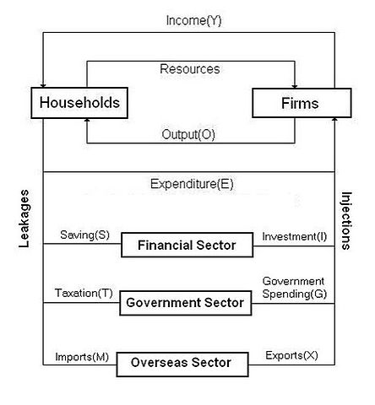

Demand Goods and Services

Supply Goods and Services

Resources

1. Which 2 sectors of the model are missing? *(2 marks) _*_______________________________________________________________________
2. What flows from households to the government sector? *(1 mark)* ____________________
3. Investment, Government Spending and Exports are all examples of INJECTIONS or LEAKAGES in the economy? *(1 mark)* ____________________________________
4. What is an alternative name for the Firms sector of the economy? *(1 mark)* __________________________

**3** An Indonesian family sends their children to university in Australia. Briefly explain the direction of the money flow in this situation and state whether it is an export or an import. *(3 marks)*

________________________________________________________________________________________________________________________________________________________________________________________________________________________________________________________________________________________________________________________________________________________________________________________________________________________________________________________________________________________________________________________________________________________________________________________________________________________________________________

**4** Briefly explain how Asia is important to Australia’s trade. *(3 marks)*

________________________________________________________________________________________________________________________________________________________________________________________________________________________________________________________________________________________________________________________________________________________________________________________________________________________________________________________________________________________________________________________________________________________________________________________________________________________________________________________________________________________________________________________________________________________________________________________________________________________________________________________________________________________________________________________________________________________________________

**5** From your studies of Investment Scams and Identity theft, list 2 similarities and 2 differences below. (You may like to use examples and statistics). *(4 marks)*

**Similarities:**

1. ________________________________________________________________________

2. ________________________________________________________________________

**Differences:**

1. ________________________________________________________________________

2. ________________________________________________________________________

**6** Read the case study below, and answer the questions that follow.

Scammers get Veronica's credit card details

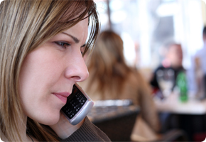Veronica was expecting a new [credit card](https://www.moneysmart.gov.au/glossary/c/credit-card) when she received a call from a man saying he was from her bank. The man apologised for the delay in sending her credit card but said he needed her to confirm the details so the card could be sent. She thought the request was a little strange but didn't question it. The man also asked her for her address and date of birth and she gave this information to him. She started to get suspicious when he hung up on her after she asked him why he was after those details. Veronica immediately called her bank, who told her that the limit on her credit card had been spent that day and her phone banking had been activated. She had never used phone banking before and had not used the card that day. The information she had given the man on the phone was enough for him to answer the bank's security questions and activate phone banking. Using phone banking, the scammer had transferred money from her savings account to her credit card so that a further cash withdrawal could be taken from her credit card. Veronica later realised that mail had been stolen from her letter box, including documents which had her full name and date of birth.

1. State what type of scam is mentioned in the case study? *(1 mark)* ______________________
2. Describe a warning sign that this was not a legitimate call to Veronica from her bank. *(2 marks)*

____________________________________________________________________________________________________________________________________________________________________________________________________________________________________________________________________________________________________________________

1. Recommend two ways that other people could do in order to protect themselves from a scam like this. Briefly describe how the strategies you suggest would help. *(4 marks)*

________________________________________________________________________________________________________________________________________________________________________________________________________________________________________________________________________________________________________________________________________________________________________________________________________________________________________________________________________________________________________________________________________________________________________________________________________________________________________________________________________________________________________________________________________________________________________________________________________________________________________________________________________________________________________________________________________________________________________________________________________________________________________________________________________________________________________________________________________________________________________________________________________________________________________________________________________________________________________________________________________________________________________________________________________________________________________________________________________________________________________________________________________________________________________________________________________________________